**BANK LOAN QUERY SUMMARIZATION**

**Dashboard 1: Summary**

**KPI:**

Total Loan Applications:



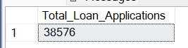

MTD Loan Applications:

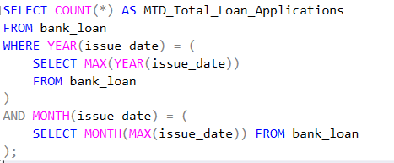



PMTD Loan Applications

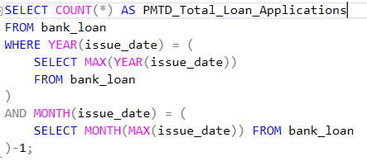



Total Funded Amount



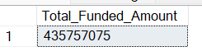

MTD Total Funded Amount

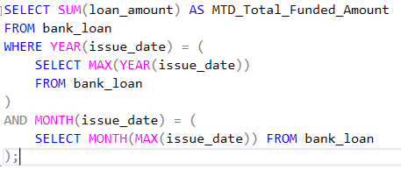

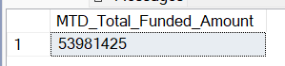

PMTD Total Funded Amount

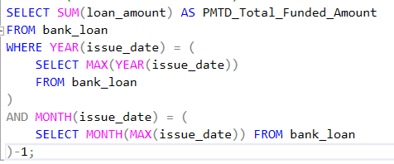

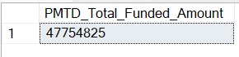

Total Amount Received



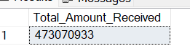

MTD Total Amount Received

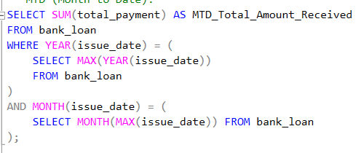

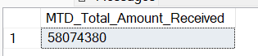

PMTD Total Amount Received

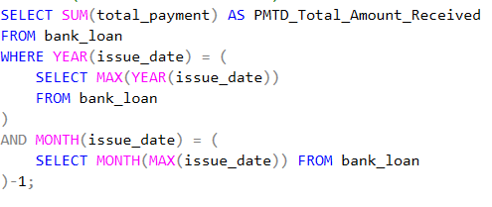

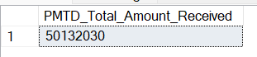

Average Interest Rate





MTD Average Interest Rate

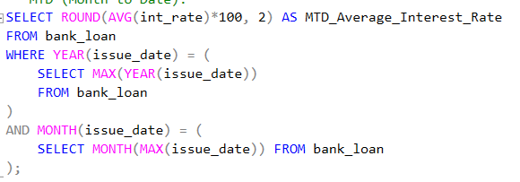

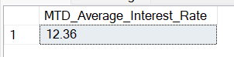

PMTD Average Interest Rate

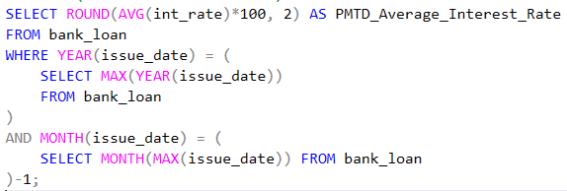

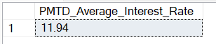

Avg DTI





MTD Avg DTI

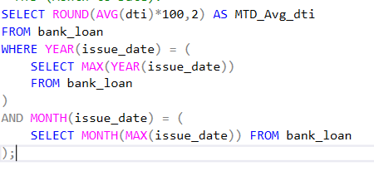



PMTD Avg DTI

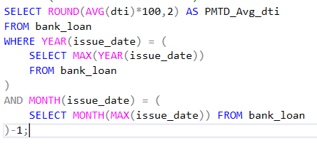



**GOOD LOAN ISSUED**

Good Loan Percentage

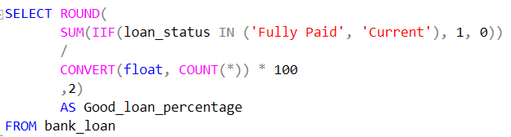



Good Loan Applications

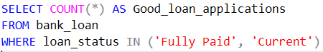

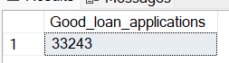

Good Loan Funded Amount

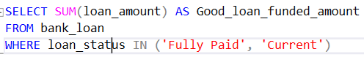



Good Loan Amount Received

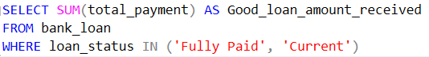



**BAD LOAN ISSUED**

Bad Loan Percentage

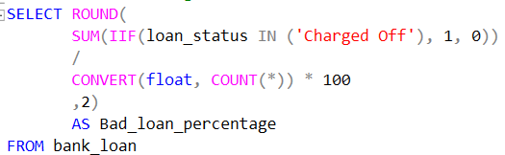

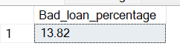

Bad Loan Applications

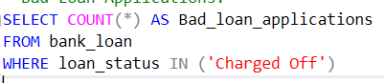

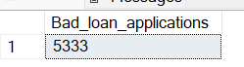

Bad Loan Funded Amount

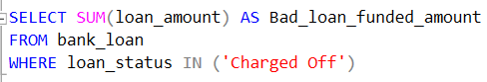



Bad Loan Amount Received

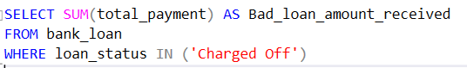



**Loan Status**

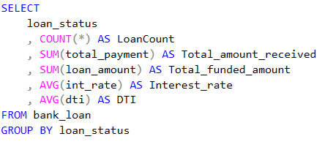

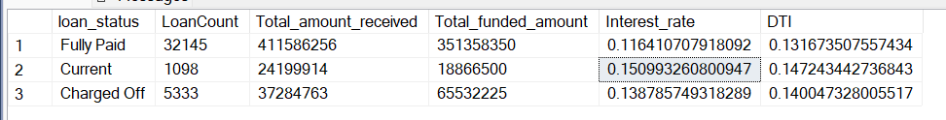

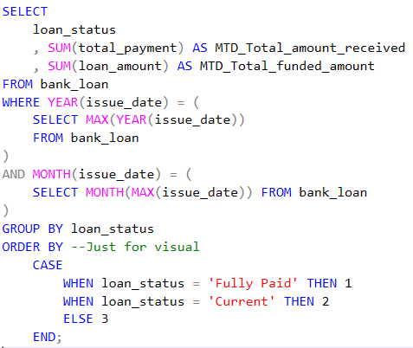

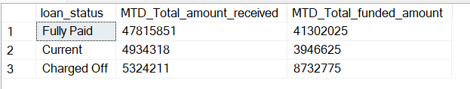

**Dashboard 2: Overview**

**Monthly Trends by Issue Date**

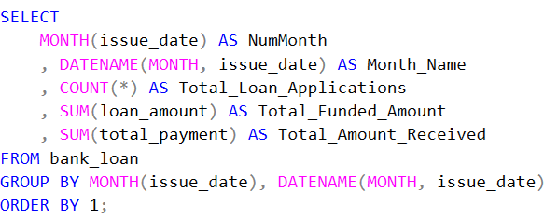

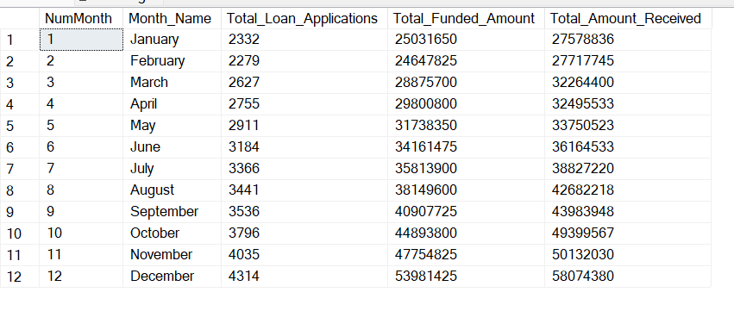

**Regional Analysis by State**

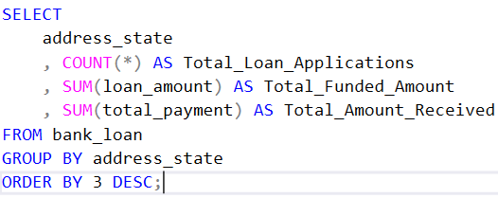

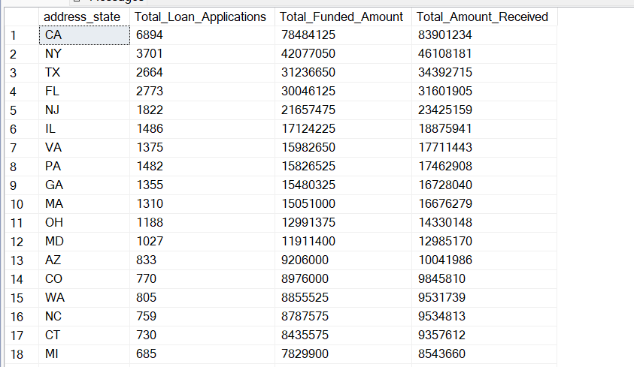

**Loan Term Analysis**

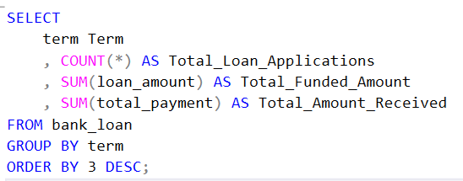

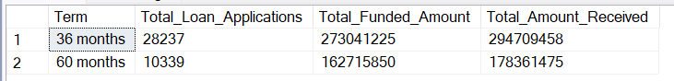

**Employee Length Analysis**

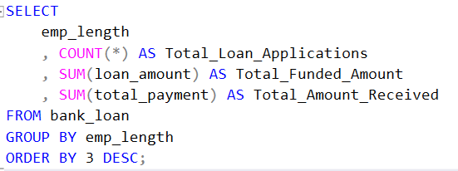

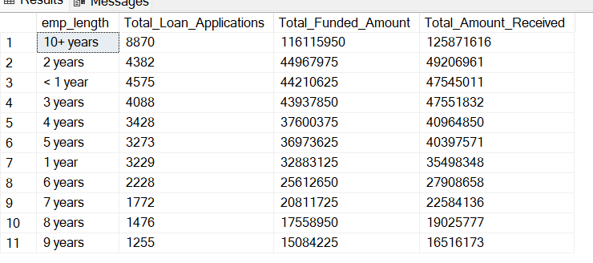

**Loan Purpose Breakdown**

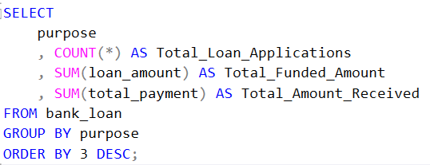

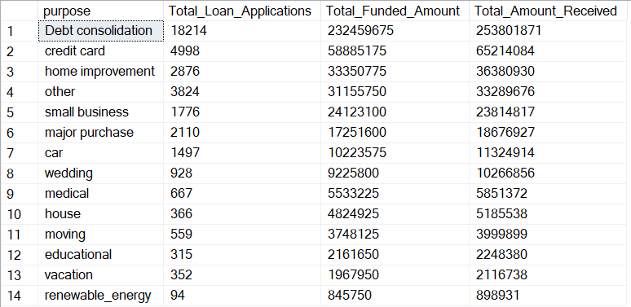

**Home Ownership Analysis**

